
East Hanningfield Pre-School
www.easthanningfieldpreschool.com
ehps1@live.co.uk
Ring us during Session: 07732951613
Newsletter
May 2025

We are enjoying the start of the summer term spending more time exploring the outside. The children have been enjoying using the mud kitchen, riding the bikes, and enjoying having lunch outside, now the warmer weather has appeared. We have been very lucky and had two beautiful benches made for us. We would like to say a huge thank you, to David Bell for making these lovely benches for the children and a huge thank you to Guards for donating the wood to make them. The children absolutely love using them, they have made a lovely addition to our outside area.
Please remember with the warmer weather, please remember sun cream and hats for the children as well as closed toe shoes, as the children are spending a lot of time outside this term.
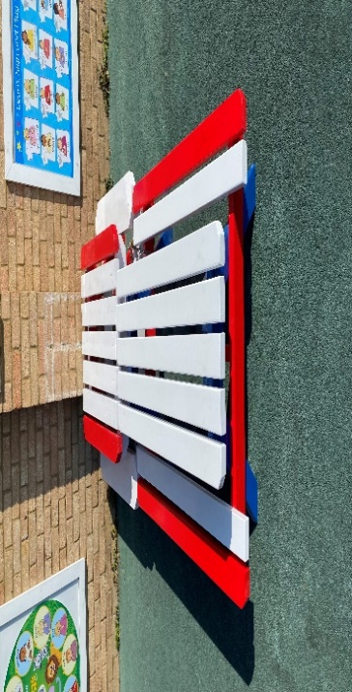
This term we will be looking at Growth and decay for our termly topic. We will be growing various items with the children, fruit, vegetables, and flowers and watch how they grow and decay. We will be looking at growth and change of insects, babies, and animals.
Dates for your Diary

Father’s Day shop Open – 9th June to 13th June
Father’s Day – Sunday 15th June
Primary school Visits: 18th June/25TH June/ 2nd July
Photos: 26th June please see Diane to book a slot, siblings welcome for early photo’s
Village Fete – Saturday 5th July
Sports day & Leavers – Monday 14th July
Last day of Term – Friday 18th July
First day of Autumn Term – Monday 8th September 2025

Please note sports day will be on Monday 14th July from 11am. Please see a member of staff to buy a ticket. Tickets are £1.50 each. This will cover your place for a seat, drink, and a sweet treat. After sports day we will be having our leavers ceremony for our school leavers.
This term we will be also helping the children with their transition to school. If there is anything you would like us to support your child with, please let us know.

#Funding

Just a note on funding, parents that are eligible to claim 30 hours funding from September. Please make sure you apply for your code before the end of summer so you can claim hours next term.
Please visit www.childcarechoices.gov.uk to apply. Unfortunately, we cannot apply on behalf of parents, you will need to apply and access a code to provide to us when we hand out funding forms.

Speech & Language support

Communication Stations continue to run across mid-Essex for children aged 2 up to the end of reception year with a Mid-Essex GP (or if they are attending a Mid-Essex school).
These are bookable in two ways:
- Parents calling up on the morning of the clinic to book a same-day appointment – please see our website for dates, locations and the number to call. https://providechildrenandfamilyservices.co.uk/services/childrens-speech-language-therapy/ please note – you do not need to complete a referral form for this.
- Parents or other professionals can complete a referral form for a pre-bookable appointment. The form for this is available on our website (just above the Communication Station dates and locations information). This was previously just for children where there were safeguarding concerns or a need for a translator but can now be for any child. Please note there is an up to 18 weeks wait for a pre-booked appointment.

Committee

Please see below our committee members below: Please feel free to speak to anyone on the committee regarding preschool any time.

Rebecca Houghton – Chairperson
Jodie Hampel– Secretary
Ana Horta – Treasurer
Ricardo Horta
Trustees
Diane Batt
Katie Kingcott
Kerry Pleasant
Jodie Hempel
Sam Morris
Lynne Philips

We always are open to new members joining our committee to help with fundraising and other preschool matters. If you are interested in joining our committee, please speak to a member of staff.

Fundraising

We have had some wonderful ideas for fundraising. Could we ask all parents and carers to sign up to Easy Fundraising, every time you shop you can raise vital funds for our preschool, all you do is sign up, once registered any purchases made through the app or website, the companies will donate to the preschool
Please find Link below: or alternatively download the app on your smart phone.

East Hanningfield Pre School - Chelmsford Fundraising | Easy fundraising

Please remember each month we do lucky ball. These little fundraising activities are little but mean so much.
Each number is £1 each, each number sold will be put into a pot to be picked out at random, the winning number will receive half the money raised, the rest will go to preschool.

Facebook
Do not forget we now have a Facebook page for passing on information so if you would like to join this please request to join as it is a closed group. It is being updated by a member of staff and a committee member.
We now also have a page set up for the public so please take a look. Reviews are welcome if you would like.

Reminders
Please let us know if your child cannot come in for their usual session due to illness, holiday, or any other reason. We will ring you to check if we have an unexplained absence by 10am. This is in line with our safeguarding policies.

Please continue to send in photos about what your child does or has been doing at home.


We have been teaching the children about good hygiene when they sneeze and not coughing over others to help reduce the spread of illness.

Other useful info…

Changing or adding hours
If you wish to change your hours, please let us know as spaces are filling up quickly. Please email us the changes even if you speak to us, and ensure you get a confirmation email from us.
If your child attends a child-minder or another setting, please let us know.

Lunchboxes
We are a nut-free pre-school so no nuts please in lunch boxes. This includes pesto. Please also check cereal bars to ensure nut-free. Please ensure your child has a drink in their lunchbox and no screw tops as these get knocked over. Please fill water bottles with water or diluted “no added sugar” squash. All chocolate and sweets are discouraged in lunchboxes.
If you put grapes in your child’s lunchbox, please ensure they are cut in half lengthwise so they can more easily pass-through smaller throats.
Please ensure you check your child’s lunchbox to see how much he/she has eaten for lunch. We cannot force your child to eat their lunch – we can only encourage. Uneaten food will be left in their lunchbox.
We promote healthy eating! If you would like further information, please see our website.

Medication
If your child requires any medication whilst at Preschool, please make sure you have filled out and signed the form “Parental Agreement for Setting to administer medicine.”

Clothing
Please do not send your child into pre-school in their best clothes as your child may get messy with paint & glue. Sometimes it is necessary for your child to have a change of clothes during the day. We do keep spare clothes but if you do borrow our clothes, please can you ensure they are returned to us.

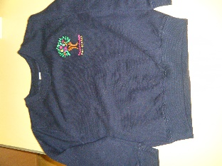
We have pre-school t-shirts for sale for £8 and sweatshirts for £11. These are embroidered with the pre-school logo. Please let us know if you would like one.

Exclusion procedure for illness and contagious diseases
In order to ensure that germs are not spread to others please visit our website page and do not send your child in to pre-school until after the exclusion period. If you have any doubts about whether your child is well enough to come into pre-school, please ring us before bringing them in.

Pre-School Bag
Please to bring your child’s personalised bag to each session so staff can fill it up with artworks, notices etc. ready for you to take home again.

Nappies
Can we please remind parents to provide nappies and wet wipes in their child’s bag.

Staff contact
If you would like to speak a member of staff, please either ring us or wait until all the children have entered pre-school. If your child comes into pre-school with a mark caused by an accident at home, please can you fill out a slip and sign it as we must record all of these.

Wow Moments
We love sharing these special moments with your child and we then place the Wow sheet in their Learning Journey. Wow sheets are available in pre-school and they can also be downloaded via our website.

www.easthanningfieldpreschool.com

Policies
All of our policies are available to read on our website.

Early Learning Journey folders
These are updated once every half-term with observations, a photo, and artworks. You are welcome to come in and view your children at any time.

Change in contact details
If you change your mobile or home telephone number, please remember to let us know so that we can update our records. This is important in case we need to contact you during a session.

