
East Hanningfield Pre-School
www.easthanningfieldpreschool.com
ehps1@live.co.uk
Ring us during Session: 07732951613
Newsletter
October 2025

A warm welcome to all. The children have settled back well this term and are enjoying playing and learning.
This term we will be looking at weather, and talking about all different weathers we experience. We will be looking at Rain, Sunshine, Storms, Wind, Hail, Sleet, Snow, Fog Rainbows, Mist, Heatwaves. Thunder and Lightning.
After half term we will then be looking at a new topic of Celebrations, looking at birthdays, Halloween, Diwali, Bonfire Night, Remembrance Day, Christmas, and New year.
Also Each week we have a Number, letter and Shape we will work around with the children.
Dates for your Diary

First day of Term Monday 8th September
Last day of Term: Friday 24th October
Diwali Festival: Monday 20Th October
Half term: 27th October – 31st October
Halloween: Friday 31st October
First day back: Monday 3rd November
Bonfire Night: 5th November
Remembrance Day: 11th November
Photo Day: Thursday 20th November
Christmas Shop open: 1st December (get your Christmas presents made from our Elves)
Christmas show: Wednesday 17th December
Christmas Party: 18th December
Last day of Term: Friday 19th December
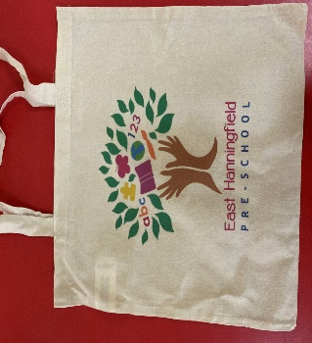
We have provided you with a preschool bag with your children’s name on it. Please can you bring this each day, so we can put the children’s artwork in to send home.

Safeguarding

Please could we remind parents on drop off and pick up, to only come through the middle door and in setting when invited to do so, this is important to ensure the safeguarding and settling of the children.
Healthy Eating

We are also talking to the children about healthy eating, please see our Eatwell Plate for ideas of different healthy food groups. Can we also request that we try to add a healthy option to children in their lunch boxes please to encourage healthy eating at preschool as well as home.

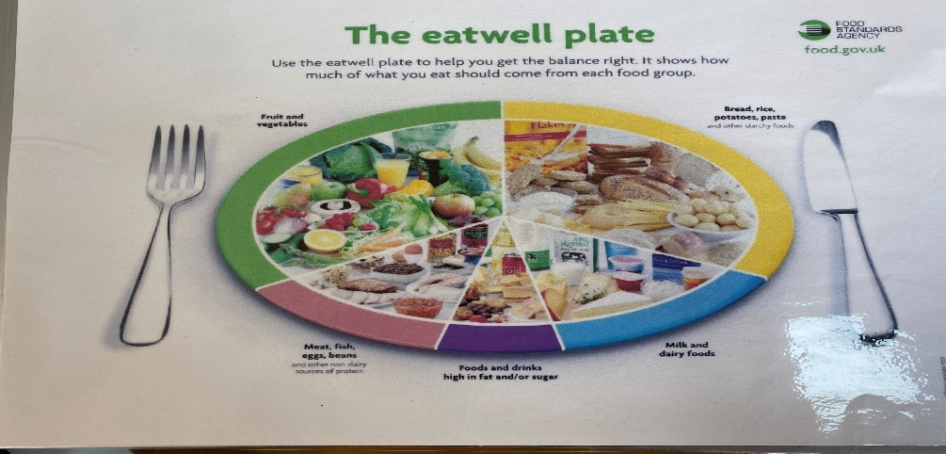

#Funding

Just a note on funding, parents that are working are eligible to claim 30 hours funding. Please inform us if you are newly entitled and have a code.

Committee

Please see below our committee members below: Please feel free to speak to anyone on the committee regarding preschool any time.

Rebecca Houghton – Chairperson
Jodie Hampel– Secretary
Ana Horta – Treasurer
Ricardo Horta
Trustees
Diane Batt
Katie Kingcott
Kerry Pleasant
Jodie Hempel
Sam Morris
Lynne Philips

We always are open to new members joining our committee to help with fundraising and other preschool matters. If you are interested in joining our committee, please speak to a member of staff.

Fundraising

Please remember each month we do lucky ball. These little fundraising activities are little but mean so much.
Each number is £1 each, each number sold will be put into a pot to be picked out at random, the winning number will receive half the money raised, the rest will go to preschool.

Could we ask all parents and carers to sign up to Easy Fundraising, every time you shop you can raise vital funds for our preschool, all you do is sign up, once registered any purchases made through the app or website, the companies will donate to the preschool
Please find Link below: or alternatively download the app on your smart phone.

East Hanningfield Pre School - Chelmsford Fundraising | Easy fundraising

Facebook
Do not forget we now have a Facebook page for passing on information so if you would like to join this please request to join as it is a closed group. It is being updated by a member of staff and a committee member.
We now also have a page set up for the public so please take a look. Reviews are welcome if you would like.

Reminders
Please let us know if your child cannot come in for their usual session due to illness, holiday, or any other reason. We will ring you to check if we have an unexplained absence by 9:45am. This is in line with our safeguarding policies.
Please continue to send in photos about what your child does or has been doing at home.


We have been teaching the children about good hygiene when they sneeze and not coughing over others to help reduce the spread of illness.

Other useful info…

Changing or adding hours
If you wish to change your hours, please let us know as spaces are filling up quickly. Please email us the changes even if you speak to us, and ensure you get a confirmation email from us.
If your child attends a child-minder or another setting, please let us know.

Lunchboxes
We are a nut-free pre-school so no nuts please in lunch boxes. This includes pesto. Please also check cereal bars to ensure nut-free. Please ensure your child has a drink in their lunchbox and no screw tops as these get knocked over. Please fill water bottles with water or diluted “no added sugar” squash. All chocolate and sweets are discouraged in lunchboxes.
If you put grapes in your child’s lunchbox, please ensure they are cut in half lengthwise so they can more easily pass-through smaller throats.
Please ensure you check your child’s lunchbox to see how much he/she has eaten for lunch. We cannot force your child to eat their lunch – we can only encourage. Uneaten food will be left in their lunchbox.
We promote healthy eating! If you would like further information, please see our website.

Medication
If your child requires any medication whilst at Preschool, please make sure you have filled out and signed the form “Parental Agreement for Setting to administer medicine.”

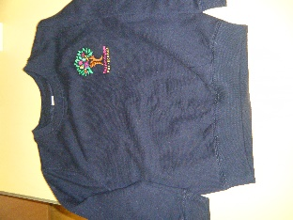
Clothing
Please do not send your child into pre-school in their best clothes as your child may get messy with paint & glue. Sometimes it is necessary for your child to have a change of clothes during the day. We do keep spare clothes but if you do borrow our clothes, please can you ensure they are returned to us.

We have pre-school t-shirts for sale for £8 and sweatshirts for £11. These are embroidered with the pre-school logo. Please let us know if you would like one.

Exclusion procedure for illness and contagious diseases
In order to ensure that germs are not spread to others please visit our website page and do not send your child in to pre-school until after the exclusion period. If you have any doubts about whether your child is well enough to come into pre-school, please ring us before bringing them in.

Pre-School Bag
Please to bring your child’s personalised bag to each session so staff can fill it up with artworks, notices etc. ready for you to take home again.

Nappies
Can we please remind parents to provide nappies and wet wipes in their child’s bag.

Staff contact
If you would like to speak a member of staff, please either ring us or wait until all the children have entered pre-school. If your child comes into pre-school with a mark caused by an accident at home, please can you fill out a slip and sign it as we must record all of these.

Policies
All of our policies are available to read on our website.

Early Learning Journey folders
These are updated once every half-term with observations, a photo, and artworks. You are welcome to come in and view your children at any time.

Change in contact details
If you change your mobile or home telephone number, please remember to let us know so that we can update our records. This is important in case we need to contact you during a session.

